APPENDIX 1 : SPECIFICATION & PRICES

Location | CH III-200 | CH III- 300 | CH2 | Total
Dock | 33 | 21 | 12 | 66
Shutter | 44 | 29 | 15 | 88

AMC Quotation
Subject: Offer for Non Comprehensive Annual Maintenance Contract (AMC) for Rolling shutter & Dock Leveller
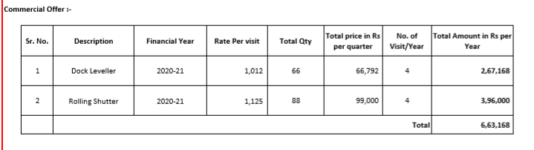
The above pricing is excluding GST
SCOPE OF WORK:
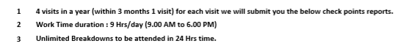

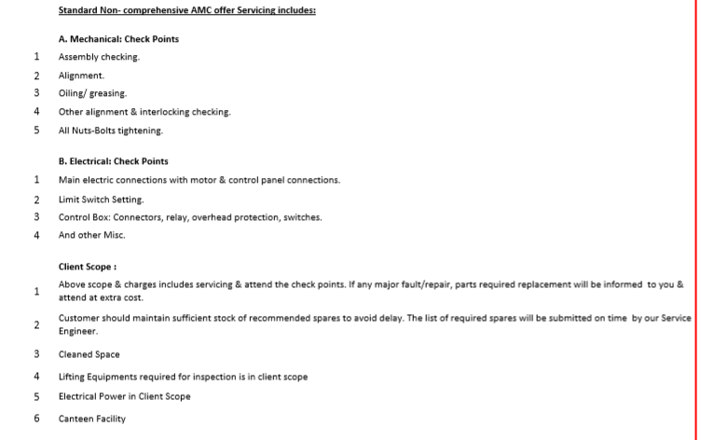
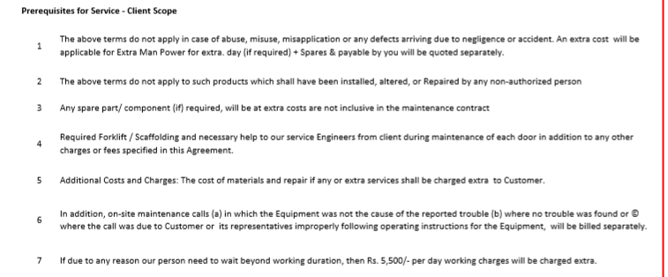
SPARE PARTS QUOTATION TO BE INCLUDED HERE

